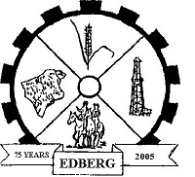**Agenda**

Village of Edberg

Regular Council Meeting

Wednesday, January 29, 2025 at 7:00 PM

At the Village Office

1. Call to Order
2. Approval of the Agenda
3. Delegations
4. Previous Minutes
5. Minutes of the Dec 20, 2024 Regular Council Meeting

5. Financial Reports

A. Jan 2025 Cheque List

B.

1. Information Items

7. Unfinished Business

A. Everbridge meeting

1. New Business
2. Administrator’s report
3. Operating budget
4. Budget overages
5. Pumphouse furnace
6. Edberg Library Lease Agreement

9. In Camera Session

A.

10. Committee Reports

A.

11. Round Table

12. Adjournment